

TTtt

**Path to fetch VPN Configuration details within OpenVPN Server**

Steps to follow:

1. Login to Openvpn Server using Putty



2) Switch to root user using command:

**sudo su -**

3) Go to /etc directory using command:

**cd /etc**



4) Use **ls** command to see the content under /etc

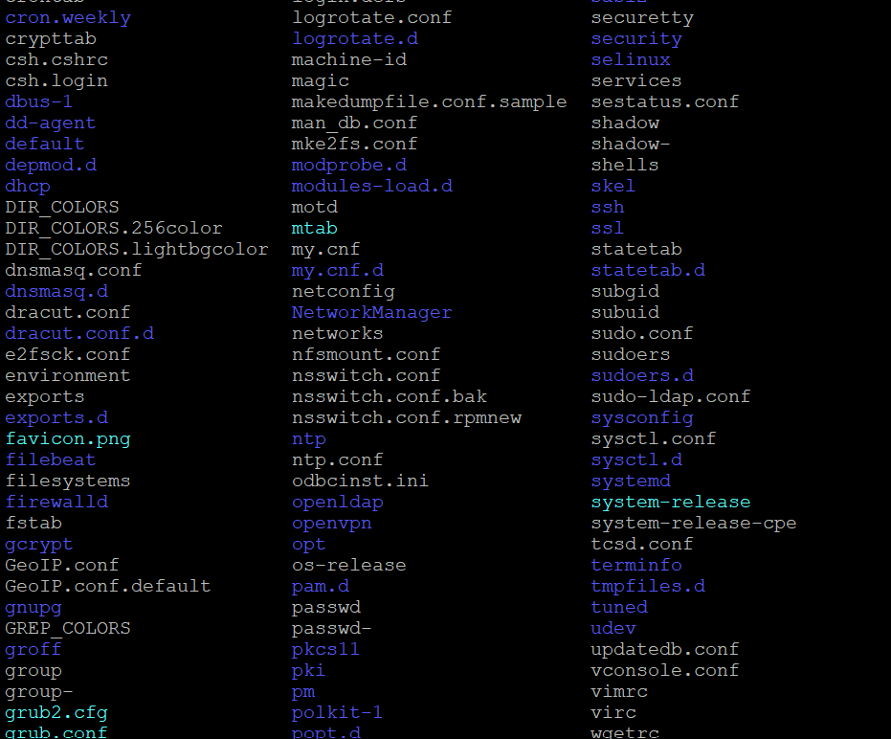

5) Go to openvpn file using command:

**cd openvpn**

6) Use **ls** command to list the content under openvpn

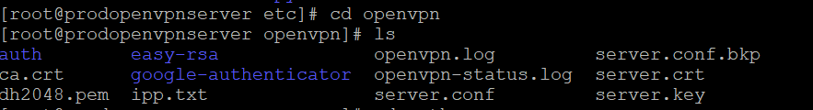

7)Now select **auth** dirctory using command:

**cd auth**

8)Use **ls** command to list the content under auth directory.

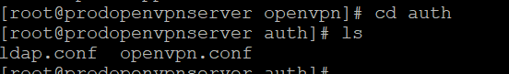

9)We will see two files under auth directory after proceeding with step 8:

ldap.conf and openvpn.conf

10) Open 'openvpn.conf' file to see the configuration of **OpenVPN which includes username and password. Use** command:

**vim openvpn.conf**

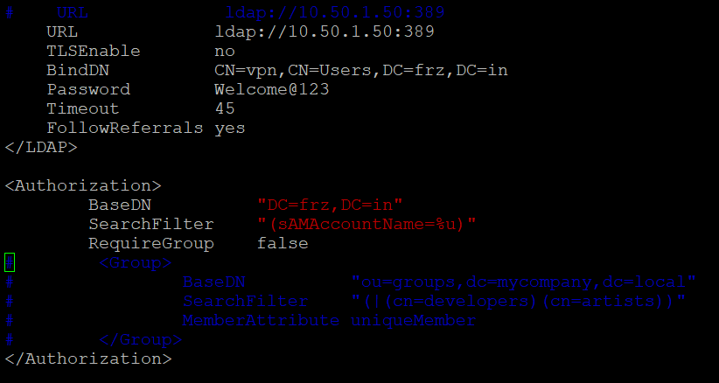

***END OF DOCUMENT***